CITY OF HENDERSON, COLLEGE OF SOUTHERN NEVADA EXPANDS ADVANCED MANUFACTURING TRAINING AT CENTER OF EXCELLENCE

New training opportunities will connect Henderson residents with hands-on skills for advanced manufacturing careers

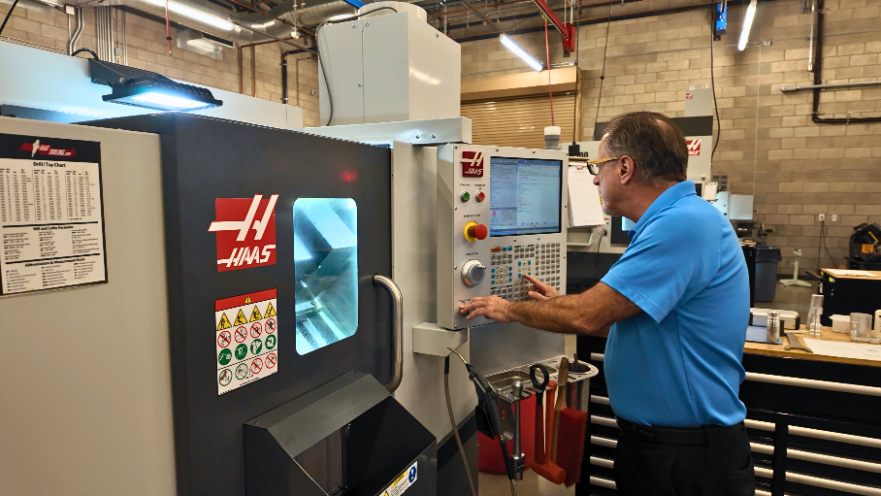

HENDERSON, Nev. (Oct. XX, 2026) — The City of Henderson and College of Southern Nevada (CSN) are expanding workforce training opportunities at the Center of Excellence in West Henderson with the addition of three advanced manufacturing programs beginning in October.

The first cohort begins Oct. 19 and will provide hands-on training for residents interested in careers in advanced manufacturing.

The programs include:
- Manufacturing Assembler Training: A four-week program focused on advanced manufacturing assembly, with curriculum developed alongside Haas trainers, hiring managers and industry executives.
- Technician: A five-week, 100-hour program providing essential technical skills for those entering advanced manufacturing careers.
- Trades Technician One: A 14-week, 180-hour program providing foundational skills for advanced manufacturing roles.

The Technician and Trades Technician One programs have a strong track record, with more than 90% of students completing their training and 100% of graduates finding employment in manufacturing roles.

“Bringing these programs to the Center of Excellence gives residents greater access to training that can connect them with career opportunities in advanced manufacturing,” said Henderson Mayor Michelle Romero. “As Henderson continues to grow, partnerships like this help prepare our workforce for the industries that are investing in our community.”

The Center of Excellence is located across the street from the future Haas facility, which is scheduled to open in January 2027. The new offerings will help build a pipeline of skilled workers for Haas and other manufacturers while supporting the continued growth of advanced manufacturing in Henderson.

“Expanding workforce training at the Debra March Center of Excellence reflects exactly what CSN is here to do: listen to our community, respond to employer needs and give students practical opportunities to prepare for in-demand careers. Through our partnership with the City of Henderson, Haas Automation and other community and industry partners, students receive hands-on technical training aligned with the skills employers are seeking. This collaboration is creating more pathways from education to meaningful careers while helping build the skilled workforce Southern Nevada needs to continue growing,” said Dr. Stacy Klippenstein, President, College of Southern Nevada.

For more information, visit cityofhenderson.com.

###

ABOUT THE CITY OF HENDERSON
Incorporated in 1953, Henderson is Nevada’s second-largest city, with more than 369,000 residents. Awarded the prestigious 2024 Malcolm Baldrige National Quality Award— the nation’s highest presidential honor for performance excellence through innovation, improvement and visionary leadership. The City is widely acclaimed for its stunning parks, trails, master-planned communities, outstanding quality of life, and patriotic past. Recognized as one of America’s Best Places to Live (MONEY and Liveability.com), one of America’s Best Cities (Business Week), one of the safest cities in America (Forbes, InsuranceProviders.com, Law Street Media, Movato.com), and a Bicycle Friendly Community (League of American Bicyclists), the City is committed to maintaining premier amenities and services for all who choose to live, learn, work and play in Henderson … a place to call home.

ABOUT COLLEGE OF SOUTHERN NEVADA
The College of Southern Nevada empowers our students and communities to achieve, succeed, and prosper. Founded in 1971, CSN is a nationally recognized student success leader specializing in two-year degrees and a select number of bachelor’s degrees in specialized fields. Connect with the state’s largest community college at news.csn.edu.

MEDIA CONTACT
Department of Communications | City of Henderson
PIO@cityofhenderson.com
O: 702-267-0746

